
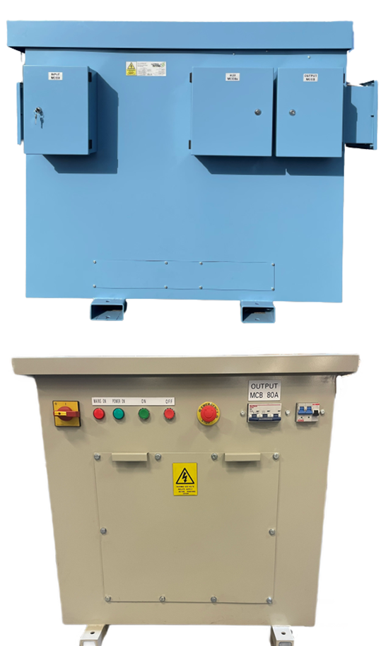
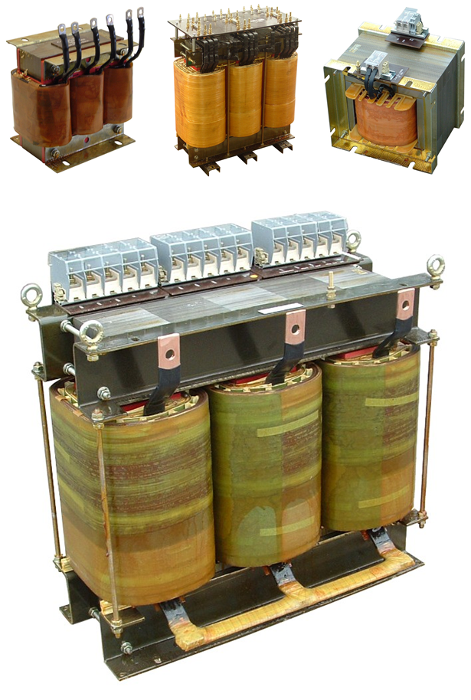

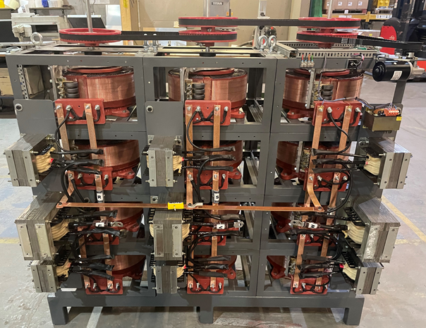
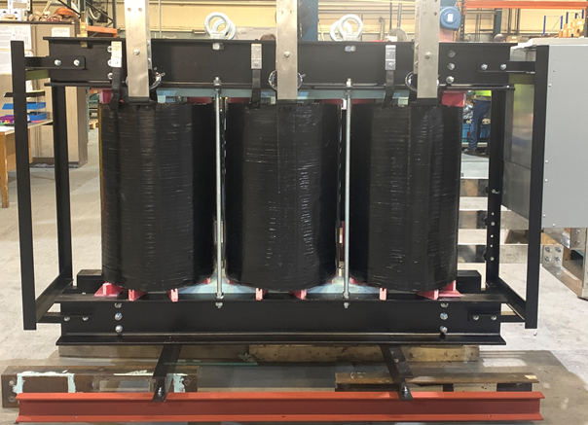
Company Profile

Carroll and Meynell Transformers Ltd have excelled in the design and manufacture of high-quality transformers and coil wound products for over 50 years, enabling us to become the market leader in the UK and abroad.
We provide power solutions to a wide range of industries, including construction, transport, mining, and power distribution.
Our engineers have a wide range of expertise, with the ability to handle the most complex magnetic applications.
Our product design emphasis is on long term operational life through reliable, technologically advanced products, and we can create solutions which produce better performance, compact size, and reduced cost to assist our customers in achieving their own operational and economic goals.

Quality
We source materials from suppliers with long standing reputations for quality, which are assembled with proven techniques.
Our manufacturing and testing procedures are operated in accordance with ISO 9001 to ensure the highest performance and reliability of all our products.
Our product design emphasis is for long term operational life.

Environmental
Carroll & Meynell Transformers Ltd operates an environmental policy in keeping with legislation covered by the following European Directives:
RoHS directive, WEEE directive, Packaging Directive, Solvent Emissions Directive.

Why choose Carroll & Meynell?
- Market leader in the UK and abroad for 52 years
- Full design and manufacturing facility based on a single site in the UK
- Our product design emphasis is for long term operational life through reliable technologically advanced products
- Wide range of expertise, ability to handle even the most complex magnetic applications.
- British manufacturer

Transformers for Industry – Oil & Gas

Carroll & Meynell Transformers have vast experience in the design, manufacture, and application of transformers for all critical and harsh environments present in on/offshore, processing, and refining operations in oil and gas sectors.

We can offer up to 1.2 MVA for single phase and up to 3MVA for three-phase transformers with a voltage range of up to 11kV. You have the option of open-style or enclosed.

We offer optional ancillaries, such as:

- Fuses
- Thermal protection,
- MCB’s, RCD’s,
- Plugs & sockets,
- Isolators
- Meters.


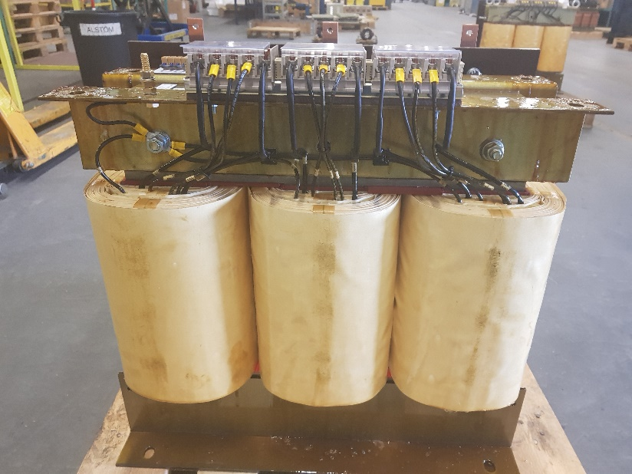
Power Rating: 30kVA
Vector: DYN11
Primary Voltage:
690V ±2.5% 415V AUX
Secondary Voltage:
3300V/ 3400V/ 3500V/ 3600V
Primary Terminals: ST05
Secondary Terminals: M6 HV Stud
Secondary Protection: Fuses & current transformers

3-Phase, Open
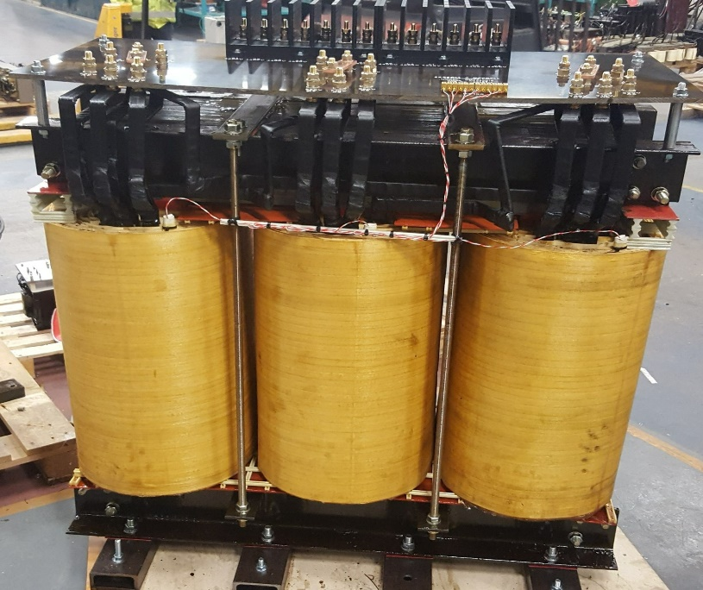
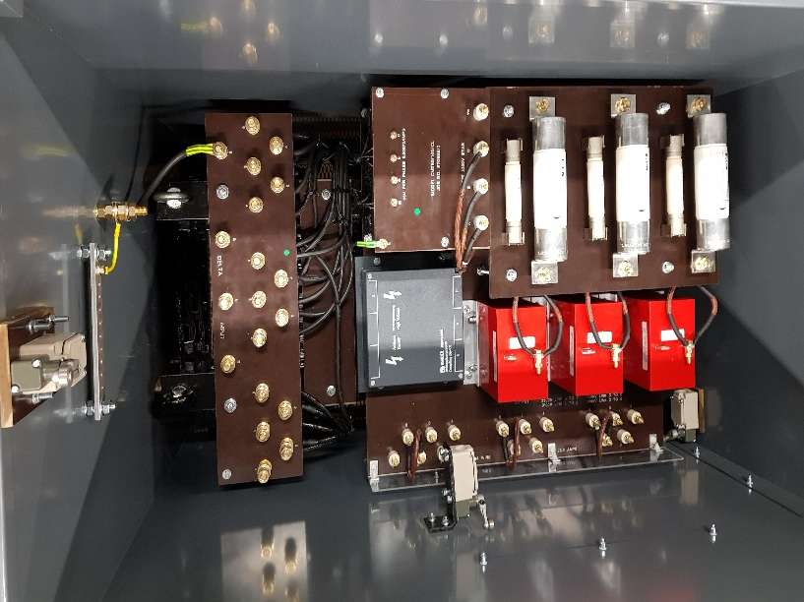
3-Phase, Open Style
Power Rating: 600kVA
Vector: DYN11
Primary Voltage:
620V/ 640V/ 660V/ 690V/ 710V/ 730V
Secondary Voltage:
4200V/ 4300V/ 4400V/ 4500V
Primary Terminals: M12 Brass Studs
Secondary Terminals:
HV Terminal Blocks

3-Phase Tropical, Enclosed
Power Rating: 180kVA
Vector: DYN11
Primary Voltage:
420V/ 440V/ 460V/ 480V
Secondary Voltage:
3000V/ 3100V/ 3200V/ 3300V
Primary Terminals: M10 Brass Studs
Secondary Terminals: 6mm HV Stud
Enclosure Rating: IP23
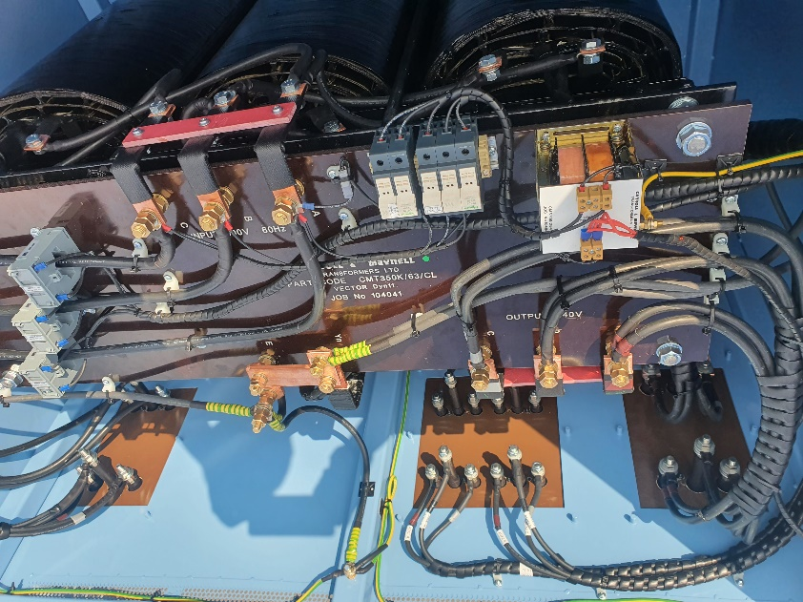
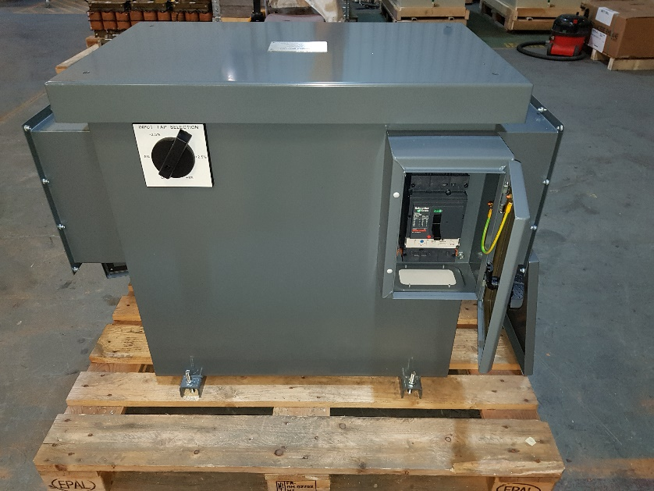
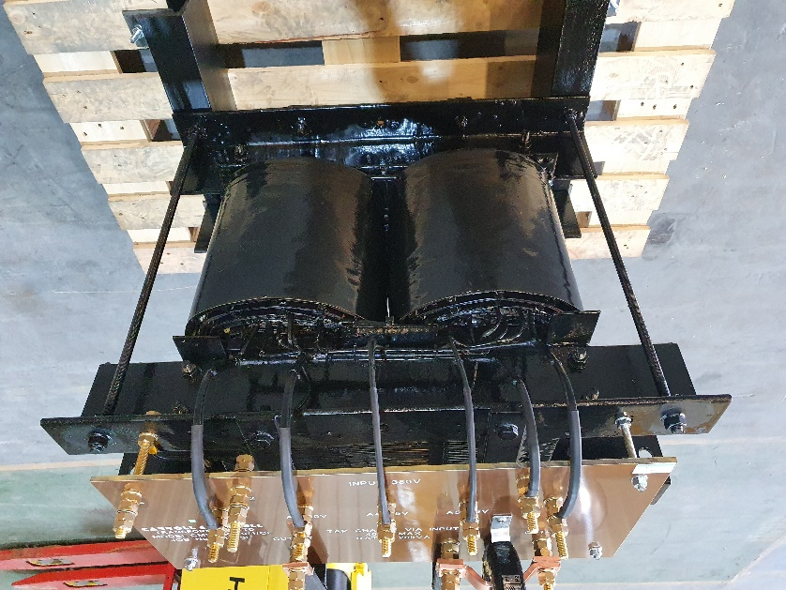
Three-Phase Tropical, Enclosed
Power Rating: 300kVA
Primary Voltage: 690V
Secondary Voltage: 240V
Primary Terminals: M12 Brass Studs
Secondary Terminals: M12 Brass Studs
Primary Protection: 400A 3P MCCB
Secondary Protection:
630A 3P MCCB + 2x AUX 100A MCCB’s
Enclosure Rating: IP23
Single-Phase- tropical, Open
Single-Phase, Enclosed
Power Rating: 25kVA
Primary Voltage:
230V ±2.5%, ±5%
Secondary Voltage: 230V
Primary Terminals:
M8 LV Studs
Secondary Terminals:
M8 LV Studs
Enclosure Rating: IP23
Single-Phase
Power Rating: 20kVA
Primary Voltage: 380V
Secondary Voltage:
60V/ 75V/ 95V/ 115V by changing primary tap
Primary Terminals:
M12 Studs
Secondary Terminals:
M12 Studs

Transformer Repairs
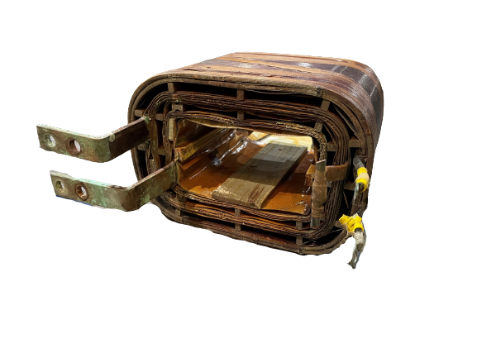
With over 52 years’ experience in transformer manufacture and repair. Here at Carroll & Meynell we have the expertise and facilities to carry out any transformer repair, including electrical evaluation, reverse engineering and redesign using modern materials.

Extra repairs options include:
- Rewinding
- Re-core
- Varnish Impregnation
- Tropicalised overcoating
- Testing & Certification

Contact Us
Office
Monday to Thursday:
08:30 – 16:30
Friday:
08:30 – 13:30

Carroll & Meynell Transformer Limited
Unit 5, Guiseley Way,
Durham Lane Industrial Park
Eaglescliffe
Stockton-On-Tees
TS16 0RF

Phone: 01642 617406
Deliveries / Collection
Monday to Thursday:
08:00 – 12:00
13:00 – 16:00
Friday:
08:00 – 13:00

Email: Sales@carroll-meynell.com
Website: Carroll & Meynell Transformers – Transformers for industry (carroll-meynell.com)
LinkedIn: https://www.linkedin.com/company/carroll-&-meynell-transfomers-ltd

